**SQL ASSIGNMENT 7**

Q1. Write an SQL query to show only odd rows from a table.

**Solution:**

Step -1. Select * from worker where worker_id%2=1;

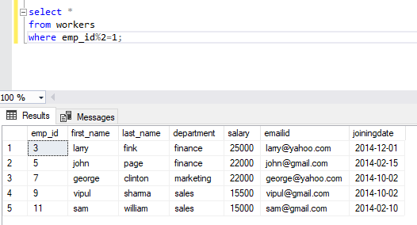

Q2. Write an SQL query to clone a new table from another table.

**Solution:**

Step-2. Select * INTO worker2 from worker.

